WHAT IS DEVOPS
DevOps is a methodology of implementing the automation on each and every stage.
DEVOPS SYLLABUS
- Git / github / gitlab
- Docker
- Kubernetes
- Terraform
- Jenkins
- Datadog

COMPANY:
A company is an organization which is created from two or more people for their profits.

COMPANY DEPARTMENTS
- HR Department
- sells Department
- IT Department
- marketing Department

IT COMPANY
- Development team (java/python/c/react – Frontend/backend)
- Tester Team (automation-selenium / manual)
- DevOps Team (infra / db / app deploy to production env / exposed public)

TYPES OF COMPANY
- service-based company
- product-based company

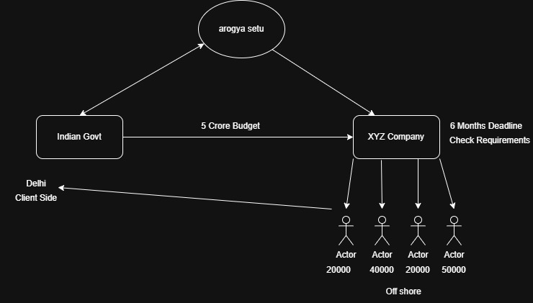

WATER FALL METHOD
it is a method of following the step-by-step integration and deployment by manually.
- The waterfall model is a sequential software development methodology.
- It is a linear approach that follows a specific order of phases, starting from requirements gathering to maintenance.
- Each phase must be completed before the next phase can begin.
- The requirements and design phases are typically very detailed and time-consuming.
- The testing phase comes after implementation, and any errors found during testing may require going back to previous phases to fix them.
- Once a phase is completed, it is difficult and costly to make changes.
- The final product is delivered after all phases are completed.
- The waterfall model is less flexible compared to Agile or DevOps methodologies.
- It is typically used for projects with well-defined requirements and a clear understanding of what the final product should look like.
- The waterfall model is still used in some industries, such as construction or manufacturing.
Drawbacks
- it’s a time consuming
- difficult to change the code after it has been created.
- without completing 1st step, we cannot go for 2nd step.
- less feedback from the client.
- high risk.
- long development cycle.
- difficult to manage complex projects.
- lack of flexibility.

AGILE METHOD (it is successor of water fall method)
it is a build short and build often process.

- Agile projects are completed in small increments or iterations, typically lasting a few weeks to a few months.
- Teams work in close collaboration with each other and with stakeholders, such as customers and product owners.
- Agile emphasizes frequent communication and feedback, with a focus on adapting to change rather than following a strict plan.
- Agile relies on self-organizing teams that are empowered to make decisions and take ownership of their work.
- Agile values working software over comprehensive documentation, although documentation is still important.
- Agile methodologies include Scrum, Kanban, and Extreme Programming (XP), among others.
- Agile can be used in a wide variety of industries and projects, from software development to marketing to construction.
- Overall, Agile is an interative and flexible approach to project management that prioritizes collaboration, communication, and customer satisfaction.
- Example: Jira

Drawbacks
- limited documentation.
- lack of predictability.
- time consuming.
- difficult for scaling, automation.
- Dependency on Client Involvement.
- Need for Skilled Team Members.

WHAT IS API (Application Programming Interface.)
it’s a way for different software programs to talk to each other.

Think of an API like a waiter in a restaurant:
- You (the user/app) place an order
- The waiter (API) takes your request to the kitchen (server/system)
- The kitchen prepares the food
- The waiter brings the response back to you
You don’t need to know how the kitchen works—you just use the menu (API).

What APIs do
APIs let applications:
- Share data
- Request services
- Connect with other systems

Why APIs matter
- Save development time (no need to build everything from scratch)
- Allow integration between services
- Power most modern apps and websites

API METHODS
- GET (Read data) - Used to fetch data from a server
- POST (Create data) - Used to send data to server and create something new
- PUT (Update data) - Used to update existing data (full update)
- DELETE (Remove data) - Used to delete data

Real-life Example (Student example)
Imagine a student database API:
- GET → See student list
- POST → Add new student
- PUT → Update student info
- DELETE → Remove student

Real-life Example on Instagram
- POST -------------> add a image on the Instagram
- GET ---------------> Read data of a post (like / comments) also scrolling reels
- PUT/PATCH -----> update the post (add a song on post)
- DELETE ----------> delete a post

